APPENDIX B - An example of Risk Assessment Form
Risk Assessment Form
Dept/Organisation: |  |  |  |  |  | RA Members:  (Names) |  |  |  |  |  |  |  |  |  |  | Ref:
Process:
Activity/Location:
RA Team Leader
Approved by:
(Name, Designation)
(Date & Signature)
 |  |  |  |  |  | Last Review Date: |  |  |  |  | Next Review Date  (Max 3 years from  Review Date):
 |  |  |  |  |  | Review Date:
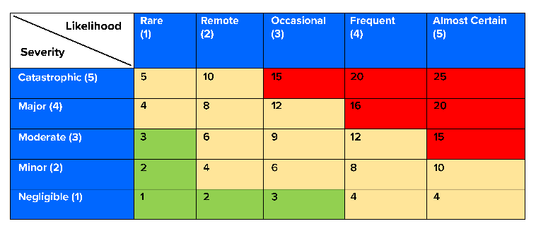  RISK MATRIX |  |  |  |  |  | SEVERITY (S) |  |  |  | - Negligible  - Minor  - Moderate  - Major  - Catastrophic |  |  | For a value of 15 to 25 (i.e. high-risk level, in red), it is essential to have control measures in place to reduce the identified hazards. For a value of 4 to 12 (i.e. medium risk level, in yellow), the risk assessment team are required to reduce the risk to as low as reasonably practicable to reduce the hazards.
 |  |  |  |  |  | LIKELIHOOD (L) |  |  |  | - Rare  - Remote  - Occasional  - Frequent  - Almost Certain
1. Hazard Identification |  |  |  |  | 2. Risk Evaluation |  |  |  |  | 3. Risk Control
No. | Work Activity | Hazard |  | Possible Accident / Ill Health & Persons-at-Risk | Existing Risk Control  (if any) |  | S | L | Risk Level | Additional Risk Control |  | S | L | Risk Level |  | Implementation  Person |  | Due Date | Remarks
1
2
3

